Day 12
Task 1:
What do you understand about data structures?
Data structures are like containers for information. Just like how you store different things in different containers (e.g., clothes in a closet, dishes in a cabinet), data structures are ways to store and organize information in a computer so that it can be used efficiently.
Think of it like your desk drawer. You can throw all your papers and documents in there, but it would be hard to find what you need when you need it. Instead, you might use folders, files, and labels to organize your papers so that you can easily find what you're looking for.
Data structures work in a similar way. They help computers store and organize information so that it can be easily accessed and used.
Task 2:
What are the types of data structures you know .. list them out..
- Arrays: A collection of elements of the same data type stored in contiguous memory locations.
- Linked Lists: A dynamic collection of elements, where each element points to the next element.
- Stacks: A Last-In-First-Out (LIFO) data structure, where elements are added and removed from the top.
- Queues: A First-In-First-Out (FIFO) data structure, where elements are added to the end and removed from the front.
- Trees: A hierarchical data structure, where each node has a value and zero or more child nodes.
  - Binary Trees: A tree data structure, where each node has at most two child nodes (left and right).
  - AVL Trees: A self-balancing binary search tree data structure.
  - B-Trees: A self-balancing search tree data structure.
- Graphs: A non-linear data structure, consisting of nodes (vertices) connected by edges.
- Hash Tables: A data structure that maps keys to values using a hash function.
- Heaps: A specialized tree-based data structure that satisfies the heap property.
- Tries: A prefix tree data structure, used for storing and retrieving strings.
TASK 3:
What all operations can we do in Data structures?
Data structures support various operations that enable you to manipulate and access the data stored within them. Here are some common operations:
- Insertion: Adding new elements to the data structure.
- Deletion: Removing existing elements from the data structure.
- Search: Finding a specific element or value within the data structure.
- Traversal: Visiting each element in the data structure, often in a specific order (e.g., inorder, preorder, postorder).
- Sorting: Rearranging the elements in the data structure in a specific order (e.g., ascending, descending).
- Updating: Modifying the value of an existing element in the data structure.
Some data structures may support additional operations, such as:
- Merging: Combining two or more data structures into a single data structure.
- Splitting: Dividing a data structure into two or more smaller data structures.
- Reversing: Reversing the order of elements in the data structure.
TASK 4:
What are static and dynamic arrays? Explain or summarize key points in a table like
Size, performance, memory, flexibility, limitations

Characteristics | Static Array | Dynamic Array
Size | Fixed size, determined at compile time | Variable size, can grow or shrink at runtime
Performance | Fast access and modification, O(1) time complexity | Fast access and modification, O(1) time complexity (amortized)
Memory | Memory allocated at compile time, can lead to wasted memory if not fully utilized | Memory allocated at runtime, can lead to memory reallocation and copying
Flexibility | Less flexible, size cannot be changed after creation | More flexible, size can be changed dynamically
Limitations | Size limit is fixed, cannot handle large or variable amounts of data | Can be slower for frequent insertions/deletions, may require memory reallocation

TASK 5:
What is the binary value of a?
Hint ascii value is 97..
Convert the decimal ASCII value to binary:
- Decimal: 97
- Binary: 01100001
So, the binary value of 'a' is 01100001.
Here's a quick way to verify:
- 64 + 32 + 1 = 97 (2^6 + 2^5 + 2^0)
Therefore, the binary representation of 'a' is indeed 01100001
TASK 6:
Types of Computer memory with examples.. Explain ..
1. RAM (Random Access Memory)
- Volatile memory: Loses its contents when power is turned off.
- Temporary storage: Holds data and applications while they are being used.
- Examples:
- DRAM (Dynamic RAM)
- SRAM (Static RAM)
2. ROM (Read-Only Memory)
- Non-volatile memory: Retains its contents even when power is turned off.
- Permanent storage: Stores firmware or software that is not meant to be changed.
- Examples:
- BIOS (Basic Input/Output System)
- Firmware for embedded systems
3. Cache Memory
- Small, fast memory: Stores frequently accessed data to improve performance.
- Located between CPU and RAM: Acts as a buffer to reduce access times.
- Examples:
- Level 1 (L1) cache
- Level 2 (L2) cache
- Level 3 (L3) cache
4. Virtual Memory
- Combination of RAM and hard drive space: Uses hard drive space to supplement RAM when it is full.
- Allows for larger applications: Enables running larger applications by using hard drive space as an extension of RAM.
- Examples:
- Paging files
- Swap space
5. Flash Memory
- Non-volatile memory: Retains its contents even when power is turned off.
- Reprogrammable: Can be erased and reprogrammed.
- Examples:
- USB flash drives
- SSDs (Solid-State Drives)
- SD cards
6. Hard Drive Storage
- Non-volatile memory: Retains its contents even when power is turned off.
- Magnetic storage: Uses magnetic disks to store data.
- Examples:
- HDDs (Hard Disk Drives)
TASK 7:
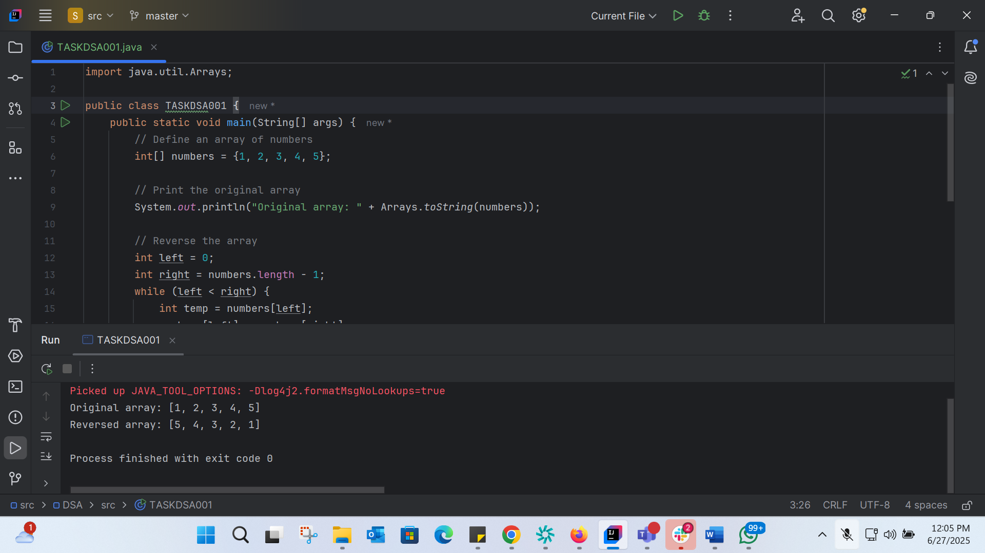
import java.util.Arrays;
public class TASKDSA001 {
public static void main(String[] args) {
// Define an array of numbers
int[] numbers = {1, 2, 3, 4, 5};
// Print the original array
System.out.println("Original array: " + Arrays.toString(numbers));
// Reverse the array
int left = 0;
int right = numbers.length - 1;
while (left < right) {
int temp = numbers[left];
numbers[left] = numbers[right];
numbers[right] = temp;
left++;
right--;
}
// Print the reversed array
System.out.println("Reversed array: " + Arrays.toString(numbers));
}
}

TASK 8:
Reverse a string .. write a code.
11.55 to 12.00
Hint: take a name from the user and display the name in reverse order..
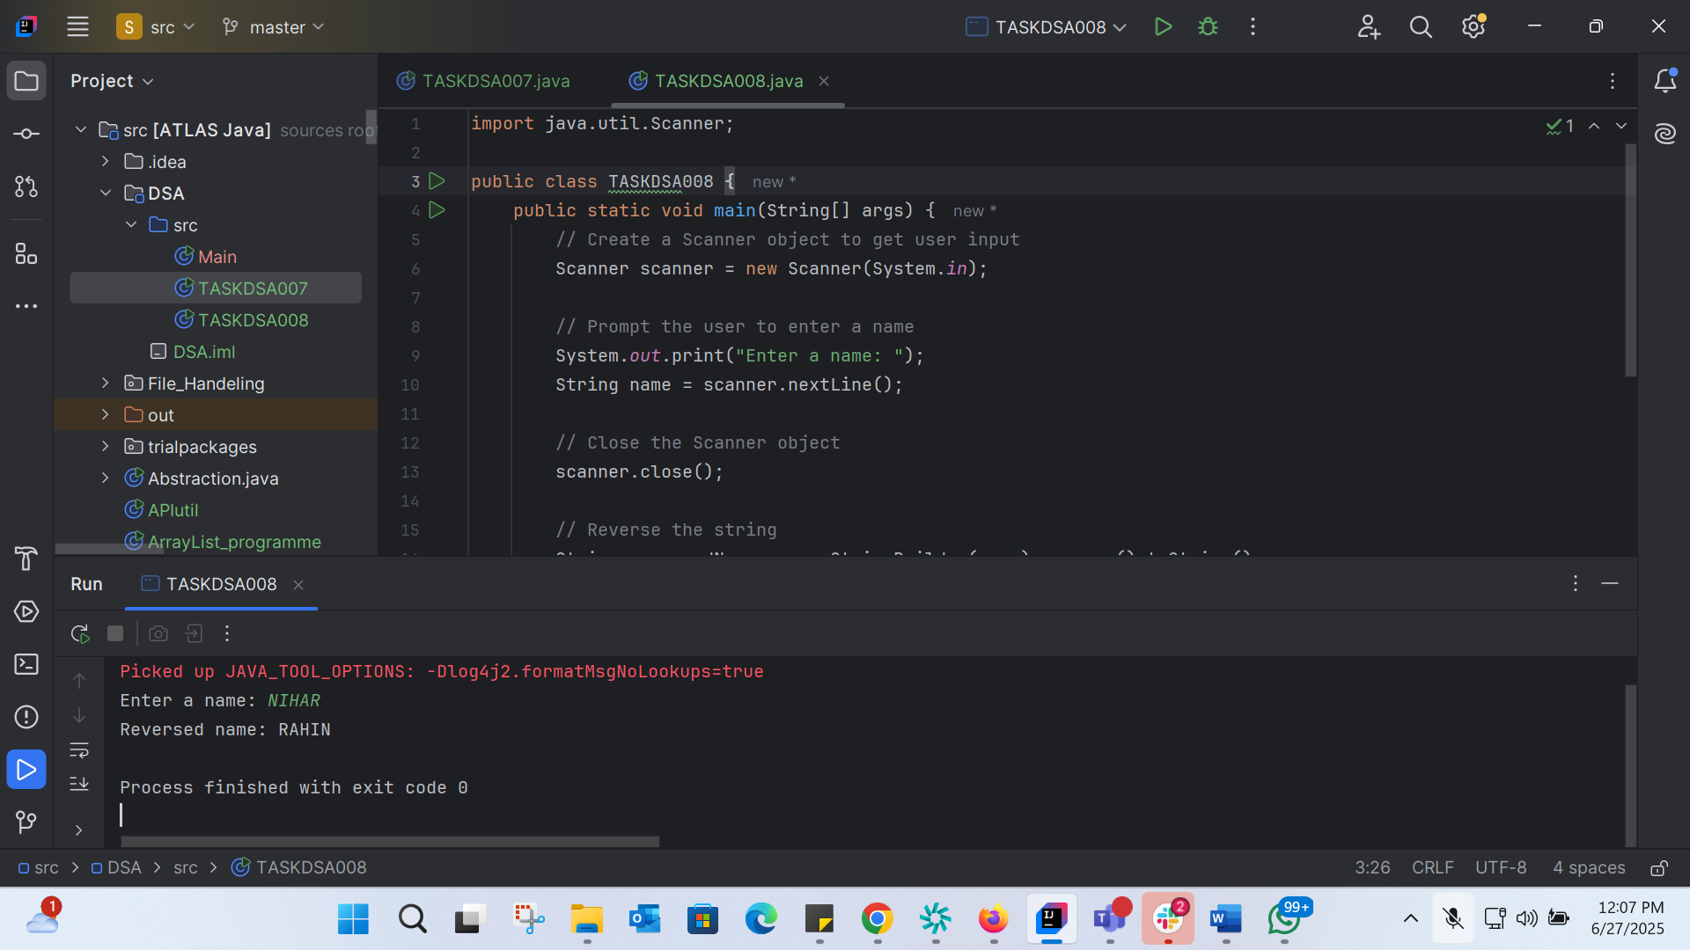
import java.util.Scanner;
public class TASKDSA008 {
public static void main(String[] args) {
// Create a Scanner object to get user input
Scanner scanner = new Scanner(System.in);
// Prompt the user to enter a name
System.out.print("Enter a name: ");
String name = scanner.nextLine();
// Close the Scanner object
scanner.close();
// Reverse the string
String reversedName = new StringBuilder(name).reverse().toString();
// Print the reversed name
System.out.println("Reversed name: " + reversedName);
}
}

TASK 9:
Register if u don’t have LEET CODE, HackerRank.
TASK 10:
public class TASKDSA010 {
public static void main (String[] args) {
int[] arr1 = {11, 34, 66, 75};
int n1 = arr1.length;
int[] arr2 = {1, 5, 19, 50, 89, 100};
int n2 = arr2.length;
int[] merge = new int[n1 + n2];
int i = 0, j = 0, k = 0, x;
System.out.print("Array 1: ");
for (x = 0; x < n1; x++)
System.out.print(arr1[x] + " ");
System.out.print("\nArray 2: ");
for (x = 0; x < n2; x++)
System.out.print(arr2[x] + " ");
while (i < n1 && j < n2) {
if (arr1[i] < arr2[j])
merge[k++] = arr1[i++];
else
merge[k++] = arr2[j++];
}
while (i < n1)
merge[k++] = arr1[i++];
while (j < n2)
merge[k++] = arr2[j++];
System.out.print("\nArray after merging: ");
for (x = 0; x < n1 + n2; x++)
System.out.print(merge[x] + " ");
}
}
Step 1: Define the input arrays
The code defines two integer arrays, arr1 and arr2, with their respective lengths n1 and n2.
Step 2: Create a new array to store the merged result
The code creates a new integer array, merge, with a length equal to the sum of n1 and n2.
Step 3: Print the original arrays
The code prints the elements of arr1 and arr2.
Step 4: Merge the arrays
The code uses a two-pointer technique to merge the two arrays. It compares elements from arr1 and arr2 and adds the smaller element to the merge array.
Step 5: Append any remaining elements
After the merge loop, the code appends any remaining elements from arr1 or arr2 to the merge array.
Step 6: Print the merged array
The code prints the elements of the merge array.

TASK 11:
Wat do u understand by Hash table?
In Java, a Hash Table is a data structure that stores key-value as pairs in a way that allows for efficient lookup, insertion, and deletion of elements. Java provides several implementations of hash tables, including:
- HashMap: A basic implementation of a hash table that stores key-value pairs.
- Hashtable: A synchronized implementation of a hash table that is thread-safe.
Key Features:
- Key-Value Pairs: Hash tables store data as key-value pairs, where each key is unique and maps to a specific value.
- Hash Function: Java's hash table implementations use a hash function to map keys to indices of an array.
- Fast Lookups: Hash tables provide fast lookups, with an average time complexity of O(1).
Common Methods:
- put(K key, V value): Adds a key-value pair to the hash table.
- get(Object key): Returns the value associated with the specified key.
- remove(Object key): Removes the key-value pair associated with the specified key.
Task 12:
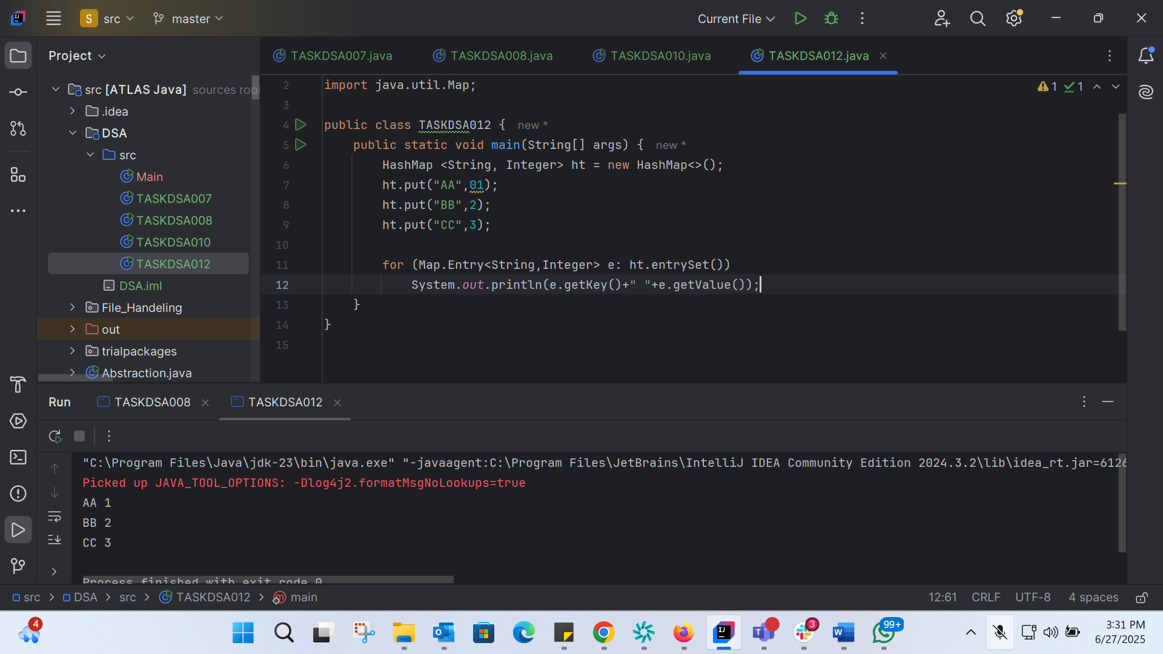
import java.util.HashMap;
import java.util.Map;
public class TASKDSA012 {
public static void main(String[] args) {
HashMap <String, Integer> ht = new HashMap<>();
ht.put("AA",01);
ht.put("BB",2);
ht.put("CC",3);
for (Map.Entry<String,Integer> e: ht.entrySet())
System.out.println(e.getKey()+" "+e.getValue());
}
}

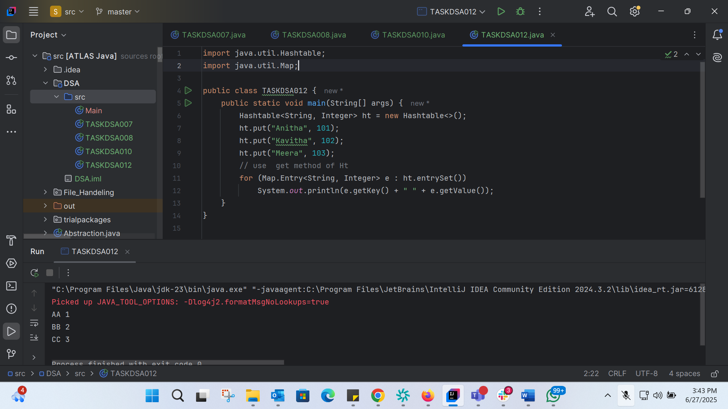
import java.util.Hashtable;
import java.util.Map;
public class TASKDSA012 {
public static void main(String[] args) {
Hashtable<String, Integer> ht = new Hashtable<>();
ht.put("Anitha", 101);
ht.put("Kavitha", 102);
ht.put("Meera", 103);
// use get method of Ht
for (Map.Entry<String, Integer> e : ht.entrySet())
System.out.println(e.getKey() + " " + e.getValue());
}
}

TASK 13:
Difference between Hasmap and HashTable:
Hashtable and HashMap are both data structures in Java that store key-value pairs using a hash table. However, there are some key differences between them:
1. Synchronization
- Hashtable is a synchronized class, which means it is thread-safe. Only one thread can access a Hashtable object at a time.
- HashMap is not synchronized, which means it is not thread-safe. Multiple threads can access a HashMap object simultaneously.
2. Null Keys and Values
- Hashtable does not allow null keys or values. If you try to put a null key or value into a Hashtable, it will throw a NullPointerException.
- HashMap allows one null key and multiple null values.
3. Performance
- Hashtable is slower than HashMap because of its synchronization overhead.
- HashMap is generally faster than Hashtable because it is not synchronized.
4. Fail-Fast Iterators
- HashMap has fail-fast iterators, which means if the map is structurally modified at any time after the iterator is created, in any way except through the iterator's own remove method, the iterator will throw a ConcurrentModificationException.
- Hashtable does not have fail-fast iterators.
When to Use Each
- Use Hashtable when you need a thread-safe map and you are working in a multithreaded environment.
- Use HashMap when you don't need synchronization and you want better performance.

Task 14:
Hash Table vs Hash Map: Differences
While often used interchangeably, "Hash Table" and "Hash Map" have some subtle differences:
1. Terminology:
- "Hash Table" typically refers to the data structure itself, which stores key-value pairs using a hash function.
- "Hash Map" often refers to a specific implementation of a hash table, such as HashMap in Java.
2. Implementation:
- Hash tables can be implemented in various ways, such as using chaining or open addressing.
- Hash maps, like HashMap in Java, are specific implementations of hash tables that provide additional features and functionality.
3. Interface:
- Hash tables typically provide basic operations like insert, delete, and search.
- Hash maps often provide a more comprehensive interface, including methods for iterating over keys, values, or entries.
Hash Table and Hash Map: Similarities
Despite the differences, hash tables and hash maps share many similarities:
1. Key-Value Pairs:
- Both hash tables and hash maps store data as key-value pairs, where each key is unique and maps to a specific value.
2. Hash Function:
- Both use a hash function to map keys to indices of an array, allowing for efficient lookup, insertion, and deletion.
3. Fast Lookups:
- Both provide fast lookups, with an average time complexity of O(1), making them suitable for applications that require quick data retrieval.
4. Efficient Insertion and Deletion:
- Both allow for efficient insertion and deletion of key-value pairs, with an average time complexity of O(1).
Task 15:

Task 16:
Try to add 1 null value in the key and run the hash map code..
Also add one more null value to the key and see the result..
make a Hashmap synchronized..

Plz note : Hash Maps are - asynchronous in nature..

Hint Map<String, Integer> syncMap = Collections.synchronizedMap(Hm1);
17.10 to 17.20